Module Name: Login and Registration Module (Automation Exercise)
Test Case ID: TC01 - TC07
Webpage URL: https://automationexercise.com/
Tester Name:
Test Management Tool: TestLink
Defect Tracking Tool: Bugzilla
Browser: Google Chrome

Scenario ID: TC01
Scenario: Verify Login Page Accessibility
Priority: High Severity: Minor
Test Steps:
- Navigate to the Automation Exercise website
- Observe the Login/Signup page
Expected Result: Login/Signup page should open successfully.
Actual Result: Pass
Screenshots:
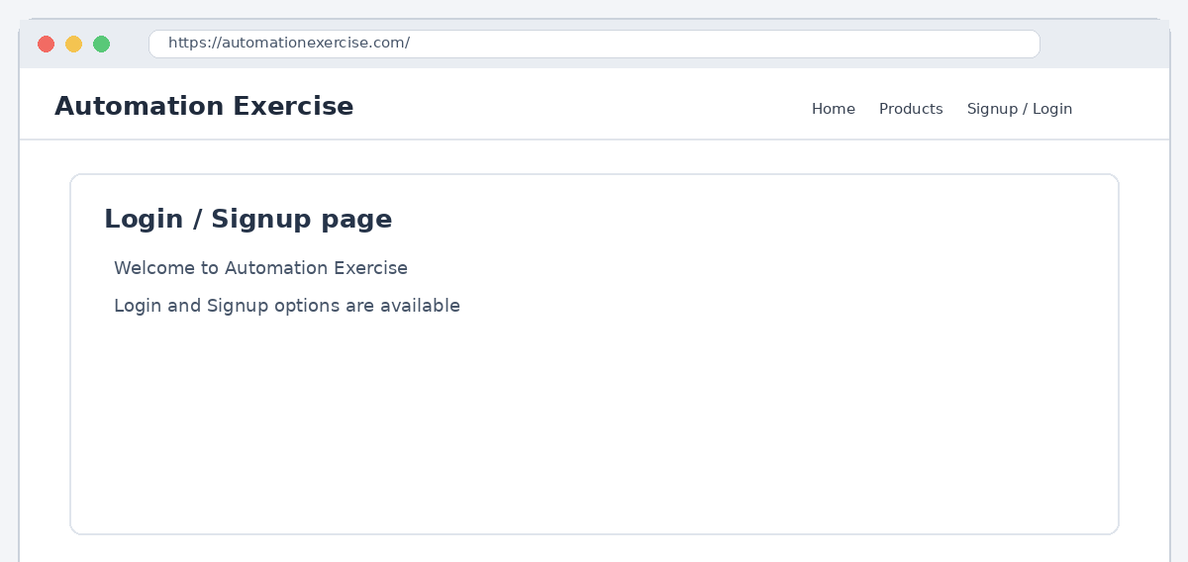

Scenario ID: TC02
Scenario: Verify Signup Page Accessibility
Priority: Medium Severity: Minor
Test Steps:
- Navigate to the Signup section
- Observe the New User Signup area
Expected Result: New User Signup section should be displayed.
Actual Result: Pass
Screenshots:
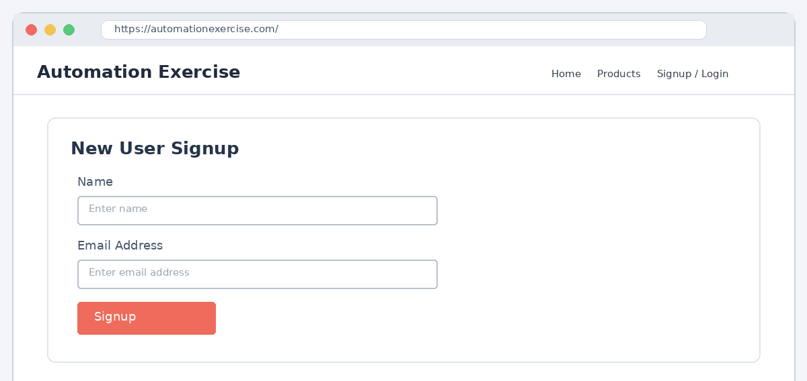

Scenario ID: TC03
Scenario: Verify Email Field Availability
Priority: Medium Severity: Minor
Test Steps:
- Open the Login/Signup page
- Check for the Email field
Expected Result: Email field should be visible and available.
Actual Result: Pass
Screenshots:
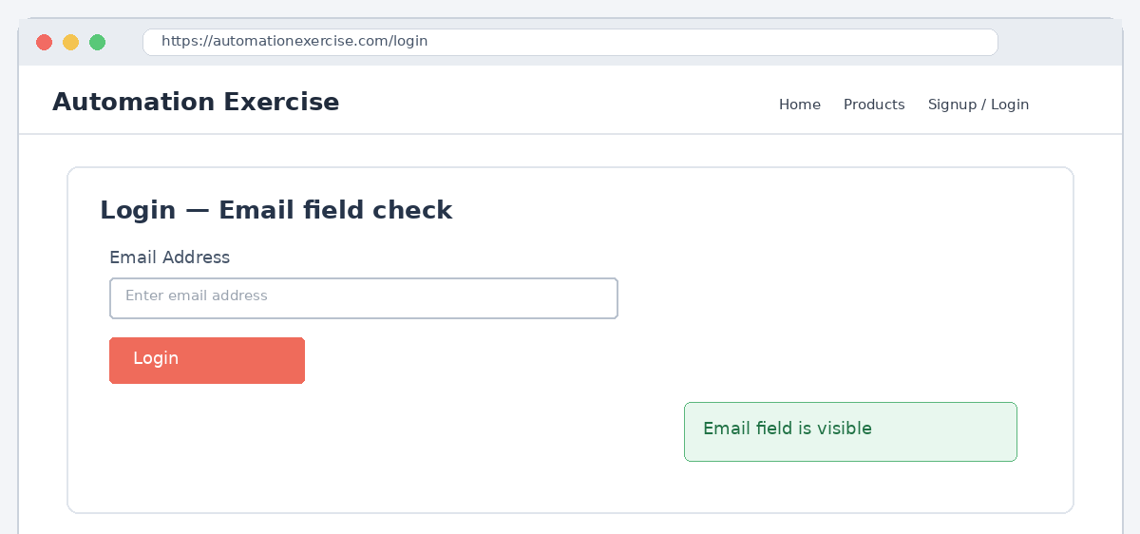

Scenario ID: TC04
Scenario: Verify Password Field Availability
Priority: Medium Severity: Minor
Test Steps:
- Open the Login page
- Check for the Password field
Expected Result: Password field should be visible and available.
Actual Result: Pass
Screenshots:
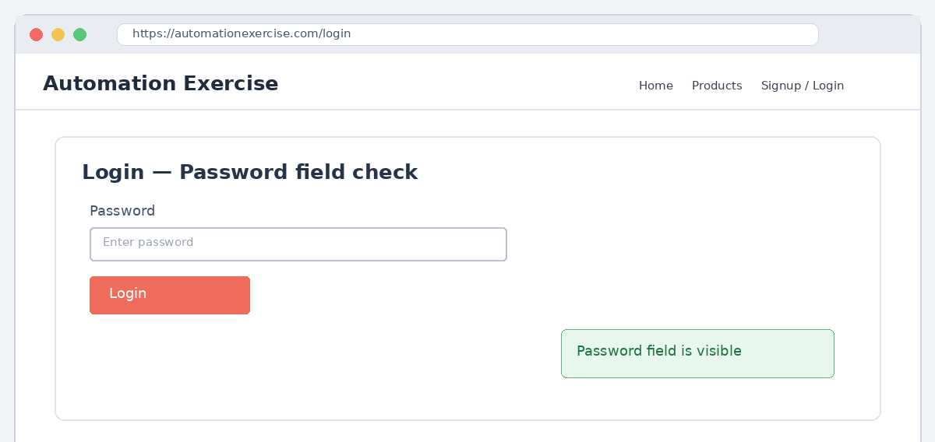

Scenario ID: TC05
Scenario: Verify Login Functionality
Priority: High Severity: Major
Test Steps:
- Enter valid Email and Password
- Click on Login button
Expected Result: User should login successfully.
Actual Result: Pass
Screenshots:
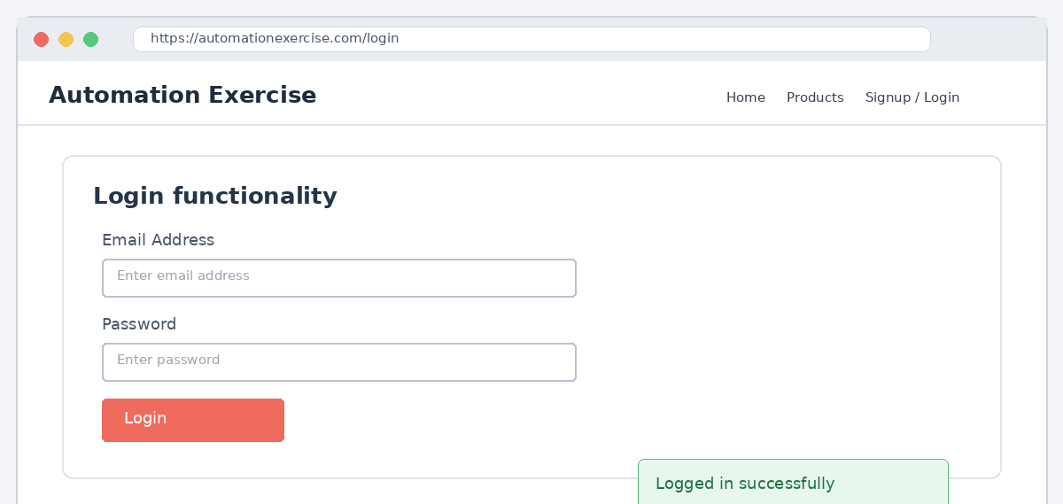

Scenario ID: TC06
Scenario: Verify Logout Functionality
Priority: High Severity: Major
Test Steps:
- Login with valid credentials
- Click on Logout
Expected Result: User should be logged out successfully.
Actual Result: Pass
Screenshots:
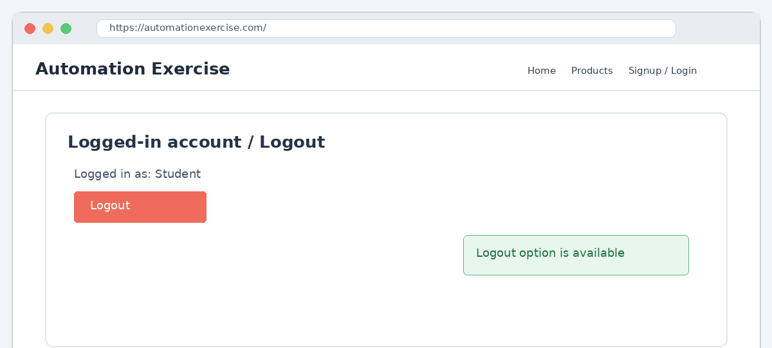

Scenario ID: TC07
Scenario: Verify Invalid Login
Priority: High Severity: Major
Test Steps:
- Enter invalid Email and/or Password
- Click on Login button
Expected Result: Invalid login should show an appropriate error message.
Actual Result: Fail (Initial) / Pass (After Retest)
Screenshots:
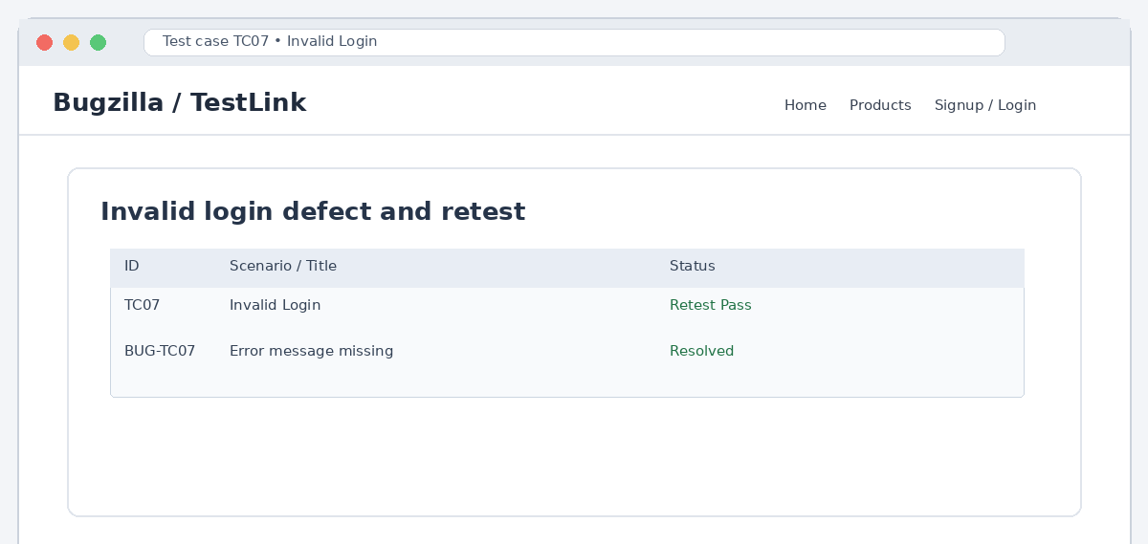

Summary Of Test Results:

Total Test Cases- 7
Passed Initially- 6
Failed Initially- 1
Defects Reported- 1
Passed After Retest- 1
Final Passed- 7
Final Failed- 0
Pass %- 100% (after retest)

Conclusion and Recommendations:
Pass Rate: 100% after retest. All test cases passed successfully following defect resolution.

Issues Found
Invalid Login Error Message Missing (TC07) The application did not display the expected error message when an invalid login attempt was made, which was reported as a defect and later fixed.

Recommendations
Improve Error Handling for Invalid Login Ensure appropriate and clear error messages are always displayed for invalid login attempts to improve user feedback.

Bug Reports:

1.
Field | Description
Bug ID | BUG-TC07
Title | Invalid password does not display proper error message
Module | Login
Severity | Major
Priority | High
Steps to Reproduce | 1. Navigate to the Login page 2. Enter an invalid email/password combination 3. Click on Login button
Expected Result | Invalid login should show an appropriate error message.
Actual Result | No appropriate error message was displayed during the negative login scenario.
Status | NEW -> ASSIGNED -> RESOLVED -> RETEST -> VERIFIED/CLOSED

